**Build Deubg and Run Guides**

# Table of Contents

Table of Contents 1

Build Guide: 2

Debug Guide: 4

Run Guide: 5

# Build Guide:

1. Open the project using Visual studio 2015
2. Press Build->Clean Solution (Not mandatory, but recommended)

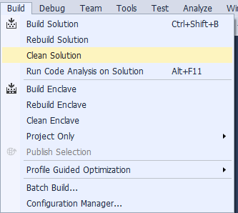

1. Chose the configuration you want (Recommended: Prerelease)

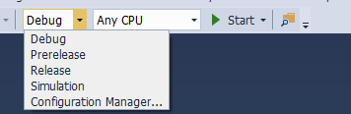

1. Chose the CPU you want (Recommended: Any CPU)

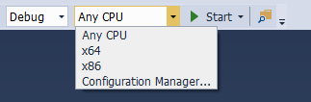

1. Press Build-> Build Solution(Ctrl+Shift+B)

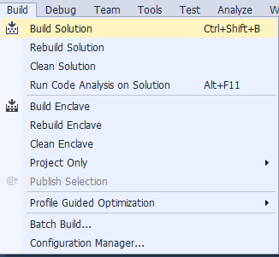

1. Wait for the process to finish

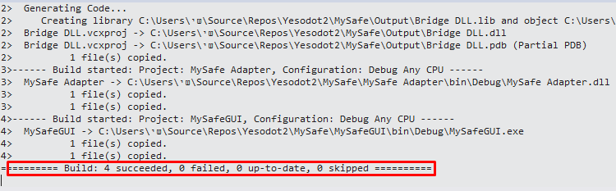

1. Done!

Comment: Release mode is not supported! And Building him won't generate the correct Output folder!

# Debug Guide:

1. Perform Build as described in the "Build Guide"
2. Press on Start when the Solution is open in Visual studio 2015

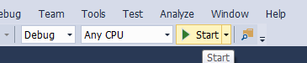

1. Done!

# Run Guide:

1. Go to the directory where the project is saved (*/MySafe/)

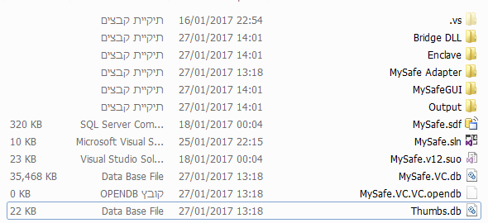

1. Go to the directory Output

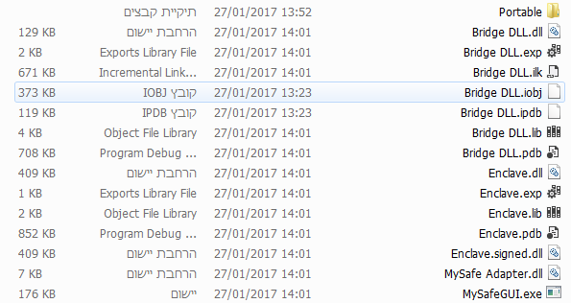

1. Go to the directory Portable

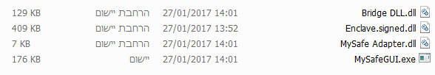

1. Run "MySafeGUI.exe"



1. Now you can take the directory Portable and put it wherever you want, and every time you want to start the program, press on "MySafeGUI.exe"
2. Done!